1. Why JPA uses EntityManager and Hibernate uses SessionFactory🡺
2. EntityManagerFactory and EntityManager. They are defined by the JPA standard.
3. SessionFactory and Session are hibernate-specific.
4. And if you need some specific features that are not available in the EntityManager, you can obtain the session by calling:
5. We can also get Hibernate's session by calling getDelegate() method from EntityManager.
6. **Note: 🡺 that unwrap() is to be preferred over getDelegate() according to the java docs:**[**javaee 6**](http://docs.oracle.com/javaee/6/api/javax/persistence/EntityManager.html#getDelegate())**, and**[**javaee 7**](http://docs.oracle.com/javaee/7/api/javax/persistence/EntityManager.html#getDelegate())**.**
7. **evict() 🡺** To detach the object from session cache
8. what is difference between evict and clear in hibernate🡺

 session.**evict** (student); will remove the object from the session while session.**clear** (); will completely **clear** the session.

1. **Close() :**Close session by calling **session.close()** method, **means End the session and releasing the JDBC Connection and clean up.**
2. Difference between delete and evict in hibernate?

**evict() deletes the data from the session only, but delete() deletes the data from both the session as well as Database.**

1. In Hibernate needed to see hbm.xml
2. In JPA needed to see Mapping.xml, Persistence.xml
3. **Entity Classes not be declared final. No methods or persistent instance variables must be declared final.**
4. **Wanted to see the example on Date type field as primary key**
5. **Wanted to see the Example for @MappedSuperClass**
6. **Wanted to see the Example for @SecondaryTable**
7. **Wanted to see the Example for IS EMPTY and MEMBER [OF], Case**
8. List of Keywords used in JPA 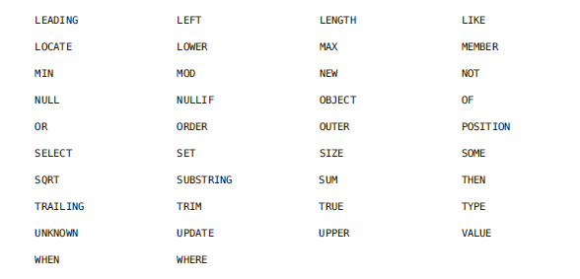
9. **What are Predicate and Expression in JPA**🡺 cq.where() method has 2 inputs type one is of Predicate type and Other Overloaded method accepts Expression